**ER Diagram for Great Groomers**

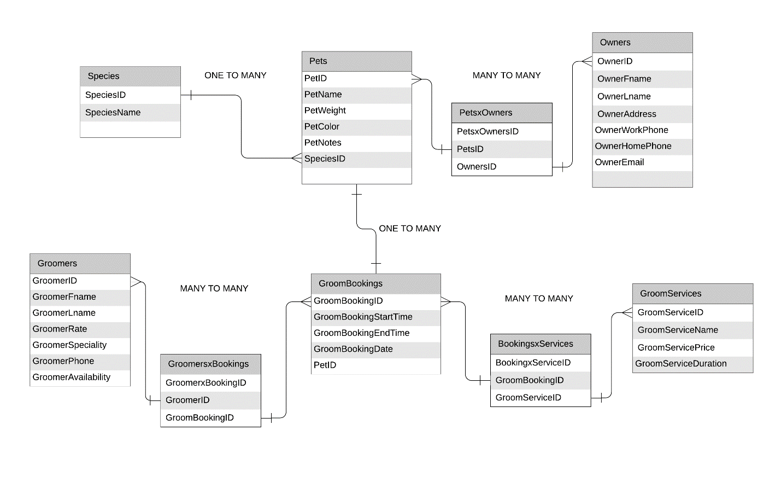

**Relationship**

**Species to Pet is one to many.**

As the first example is, the pet can only have one species such as dog or cat but a species can have many different kinds of pets. An example would be a Pet1 and Pet2 could have similar species such as a dog.

**Pets to Owners is many to many relationship**

This is my conclusion because one pet can have many owners such husband and wife, or a family with one pet and at the same time, owners can have multiple pets as much as they can.

**Pets to Bookings is a one to many relationship**

This is my conclusion as pets can have multiple bookings. An example would be a similar customer with similar pet can book again for a different date that would be a different bookingId. At the same time, booking cannot have multiple pets because different pets can have different/similar services which can have different start time. An example would be a pet owner want to have a hair-cut for his two dogs at 11:00am, but hair-cut is done for almost 30minutes each pet and there is already another booking at 11:30am. With this, the employee would book the first pet on 11:00am and the other pet would be at 12:00am, thus having different time and would have different bookingId.

**Groomers to Booking is a many to many relationship**

We can tell that a Booking can have multiple Groomers. A booking can have different services which can have different Groomers at each service. Also, Groomers can have multiple bookings because an employee who can actually do many services will actually have more bookings to work with.

**Booking to Services is a many to many relationship**

Booking can have multiple services. As a customer, you would like to do most of the services in one go. Thus, a hair-cut, a wash, or any services can ask by the customer at the same time when he/she try to book for the services. Moreover, the services can have multiple bookings. One service such as hair-cut can be book by another customer or similar customer but different time, thus creating different booking appointment.